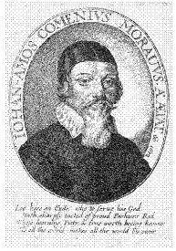
REFORMED THEOLOGICAL FACULTY
OF UNIVERSITY J SELYE
Komárno, Slovakia, 94501
Bratislavská cesta 3322

Roads to Reconciliation Between Groups in Conflict
10th Conference of Protestant Theological Faculties from Central and Eastern Europe and the Netherlands Komárno, Slovakia
20. -24. April 2016

Wege zur Versöhnung zwischen Gruppen in Konflikt

10. Konferenz Niederländischer und Mittelsüdosteuropäischer Protestantischer Theologischer Fakultäten – Komorn, Slowakei, 20. -24. April 2016

Registration Form

Name:

O female Status: O teacher
O male O student

Giving a paper: O yes O no

Institution (faculty):

Address:

Email:

Staying from till

Arrival by at (place and time)

Wishing to be collected and guided to the place of accommodation O yes O no

Applying for covering the travel costs O yes O no

If yes, state the reasons

Special wishes (dietary and other):

Please, fill in and send as an email attachment to

comconf16@gmail.com or gorozdiz@ujs.sk phone 00421 908 745 246 (D, CZ, SK, HU)
00421 915 788 593 (EN)

